**How to add members and roles to a Project**

For TERA –Initial Dash board View of Project- Only 5 people exist, only these people can review.

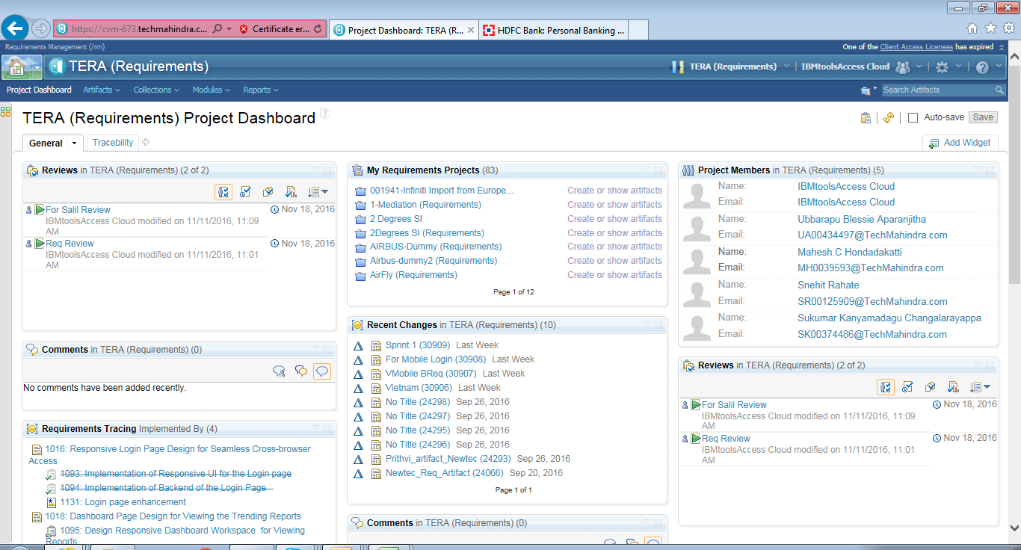

How to Add a Member:

Under Application Management – click on Manage This Project Area

Go to Members – Add

Enter the Name and Select individual or Multiple.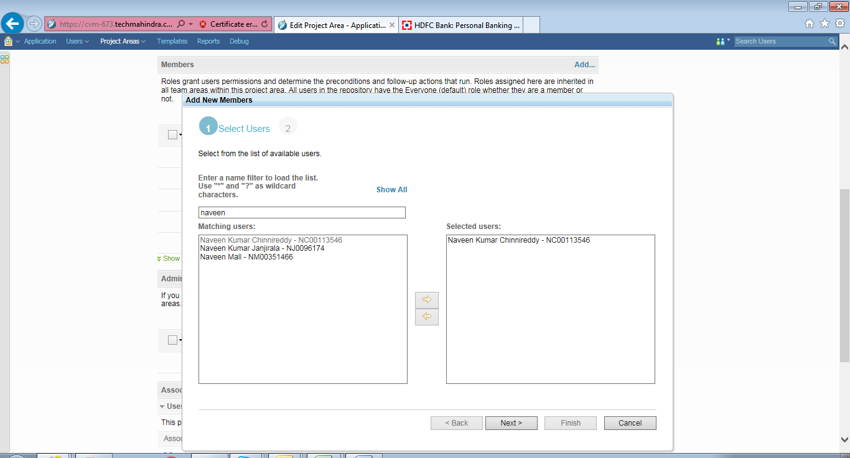

Once identified the member , now select the Roles.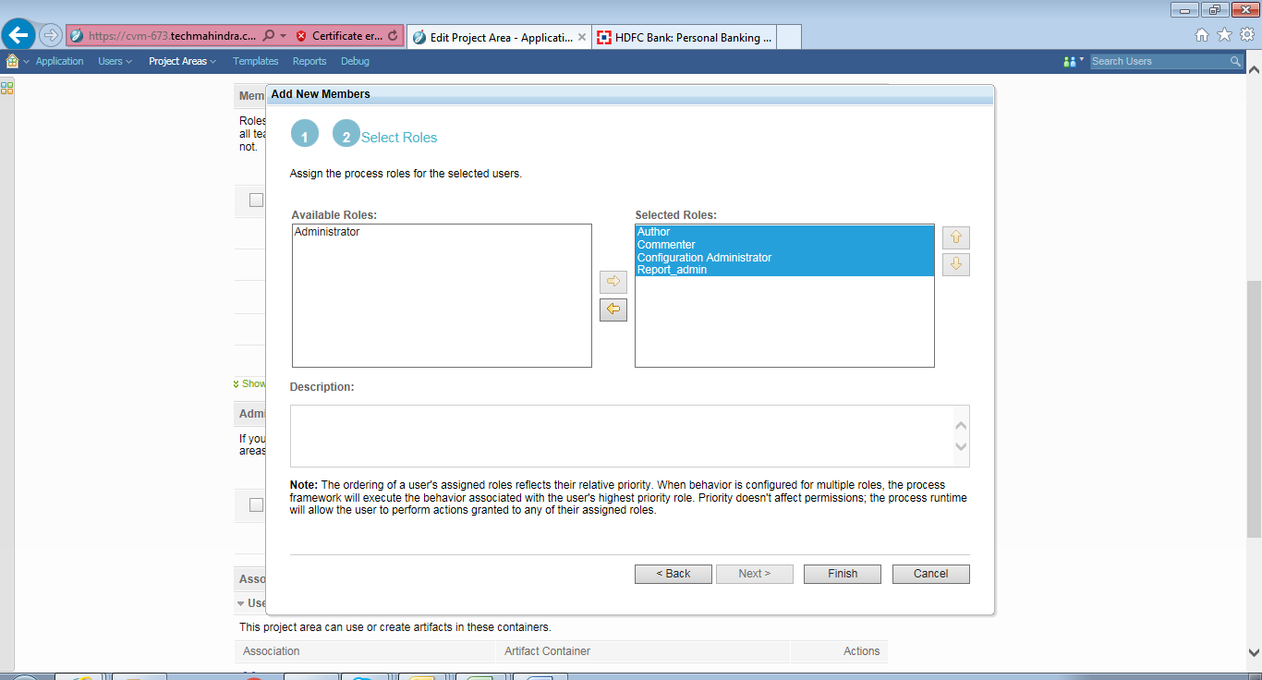

Once finished you can view list of Members:

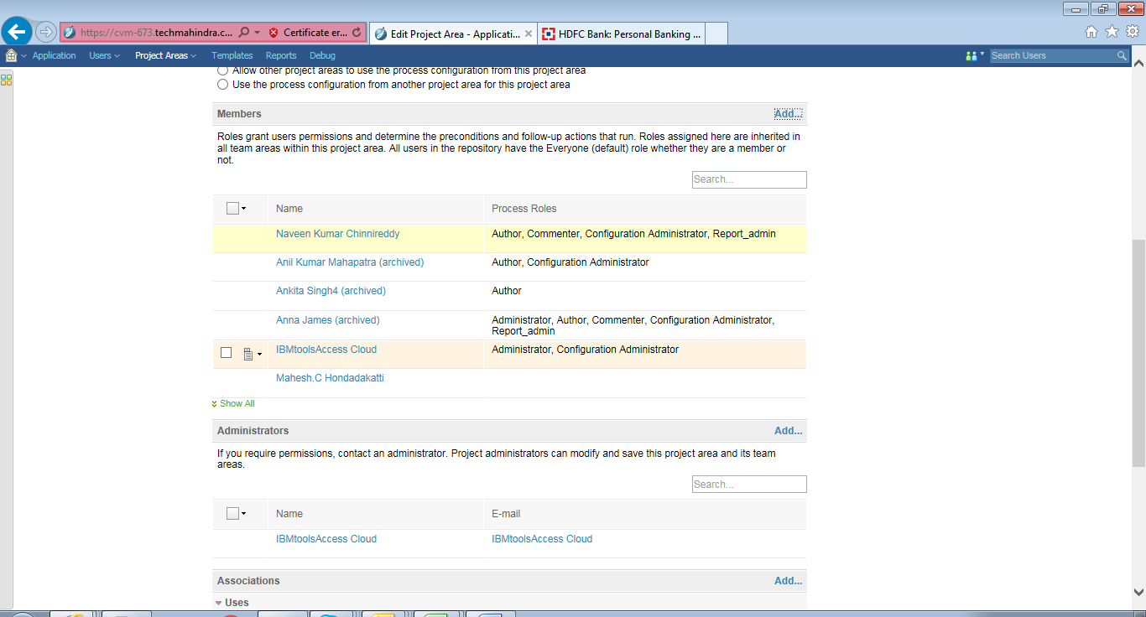

Dash Board View:

